# User Manual

**FYP Title:**

Elevating Timogah's User Experience with User Interface Improvements and Gamified Engagement for Enhanced Customer Retention and Loyalty

**Name:** Tang Jhen Nee

**Majoring:** Software Engineering

## XAMPP

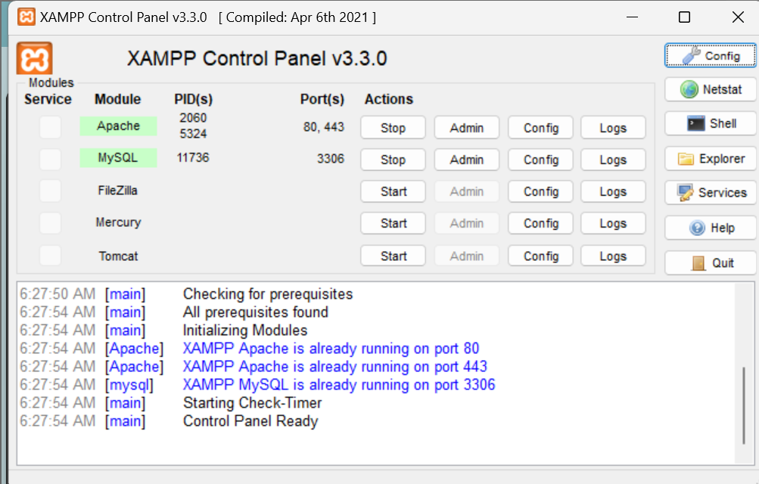

1. After installing XAMPP, the user has to run the XAMPP and Start the Apache and MySQL.

## phpMyAdmin

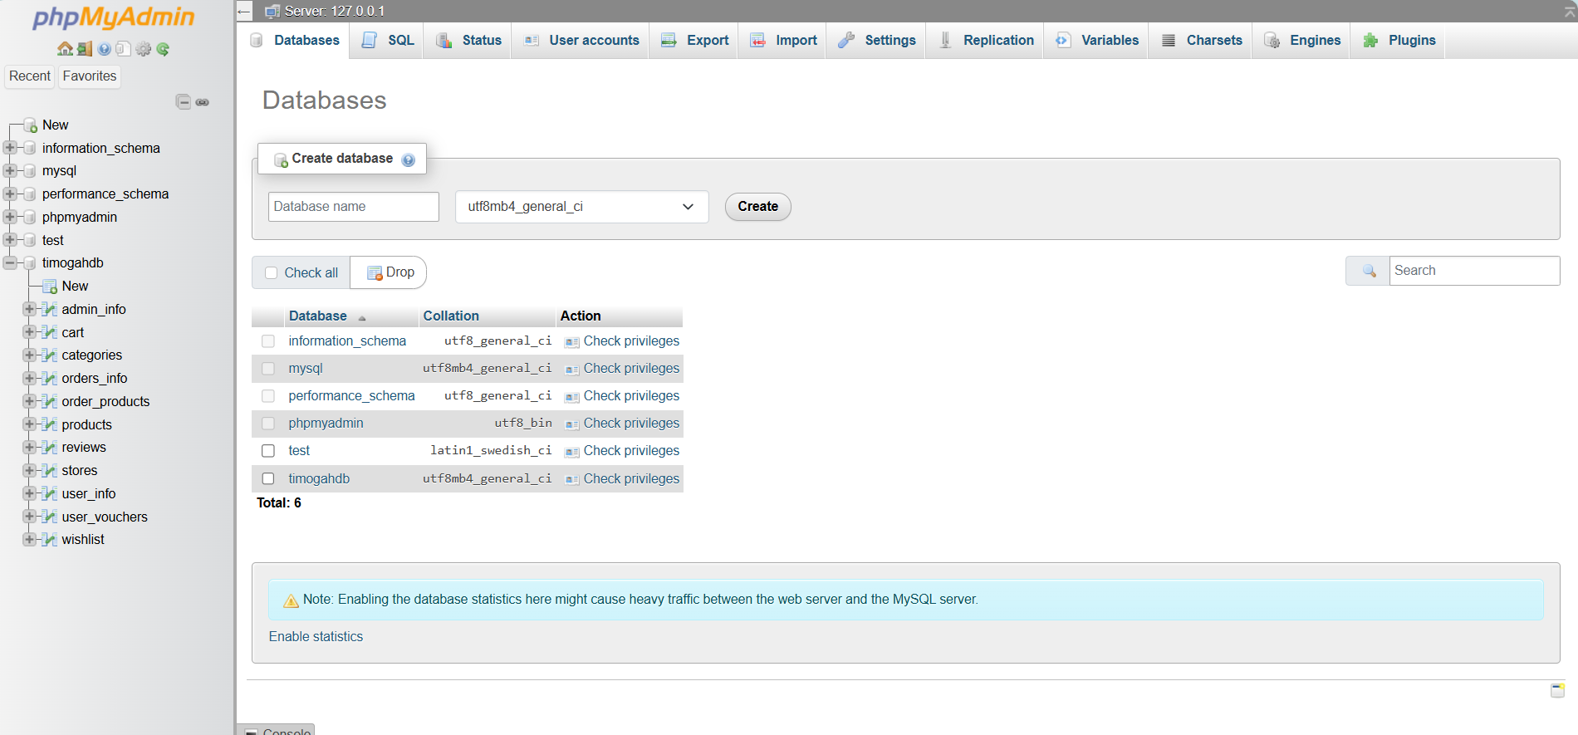

1. First, the user can use any browser to visit to the URL “http://localhost/phpmyadmin”.
2. Then, the user navigates to the “databases” tab to create new table named “timogahdb”.

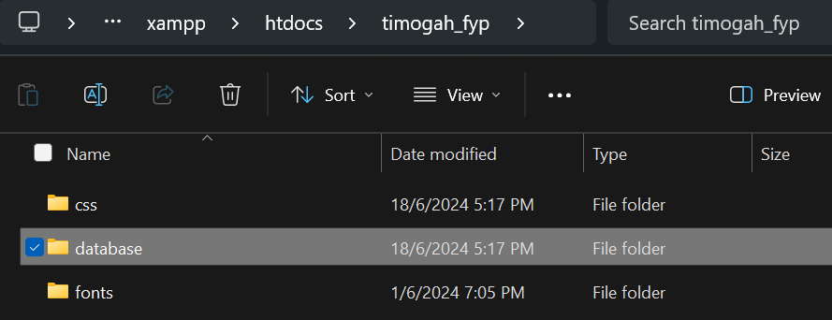

1. The user moves on to the source code folder “timogah_fyp” and search for “database” folder.

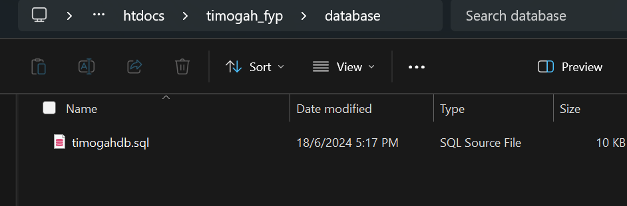

1. In the “database” folder, there is “timogahdb.sql” file.

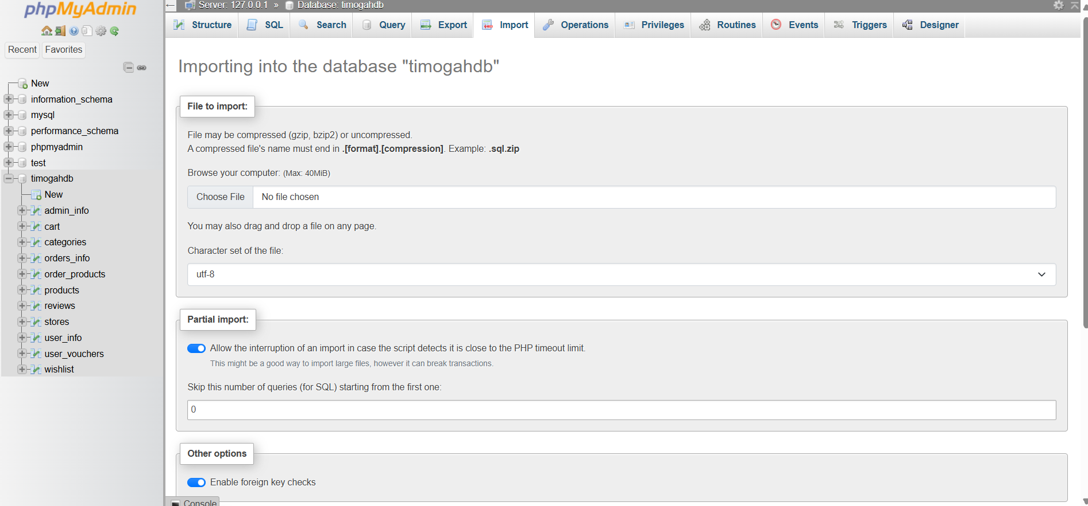

1. The user then navigates to the “import” tab to import “timogahdb.sql” file.
2. After done importing SQL file, the database is settled.

## Timogah Web Application

To access to the Timogah Web Application, the user access to the URL “http://localhost /timogah_fyp/” in any browser.

### Guest

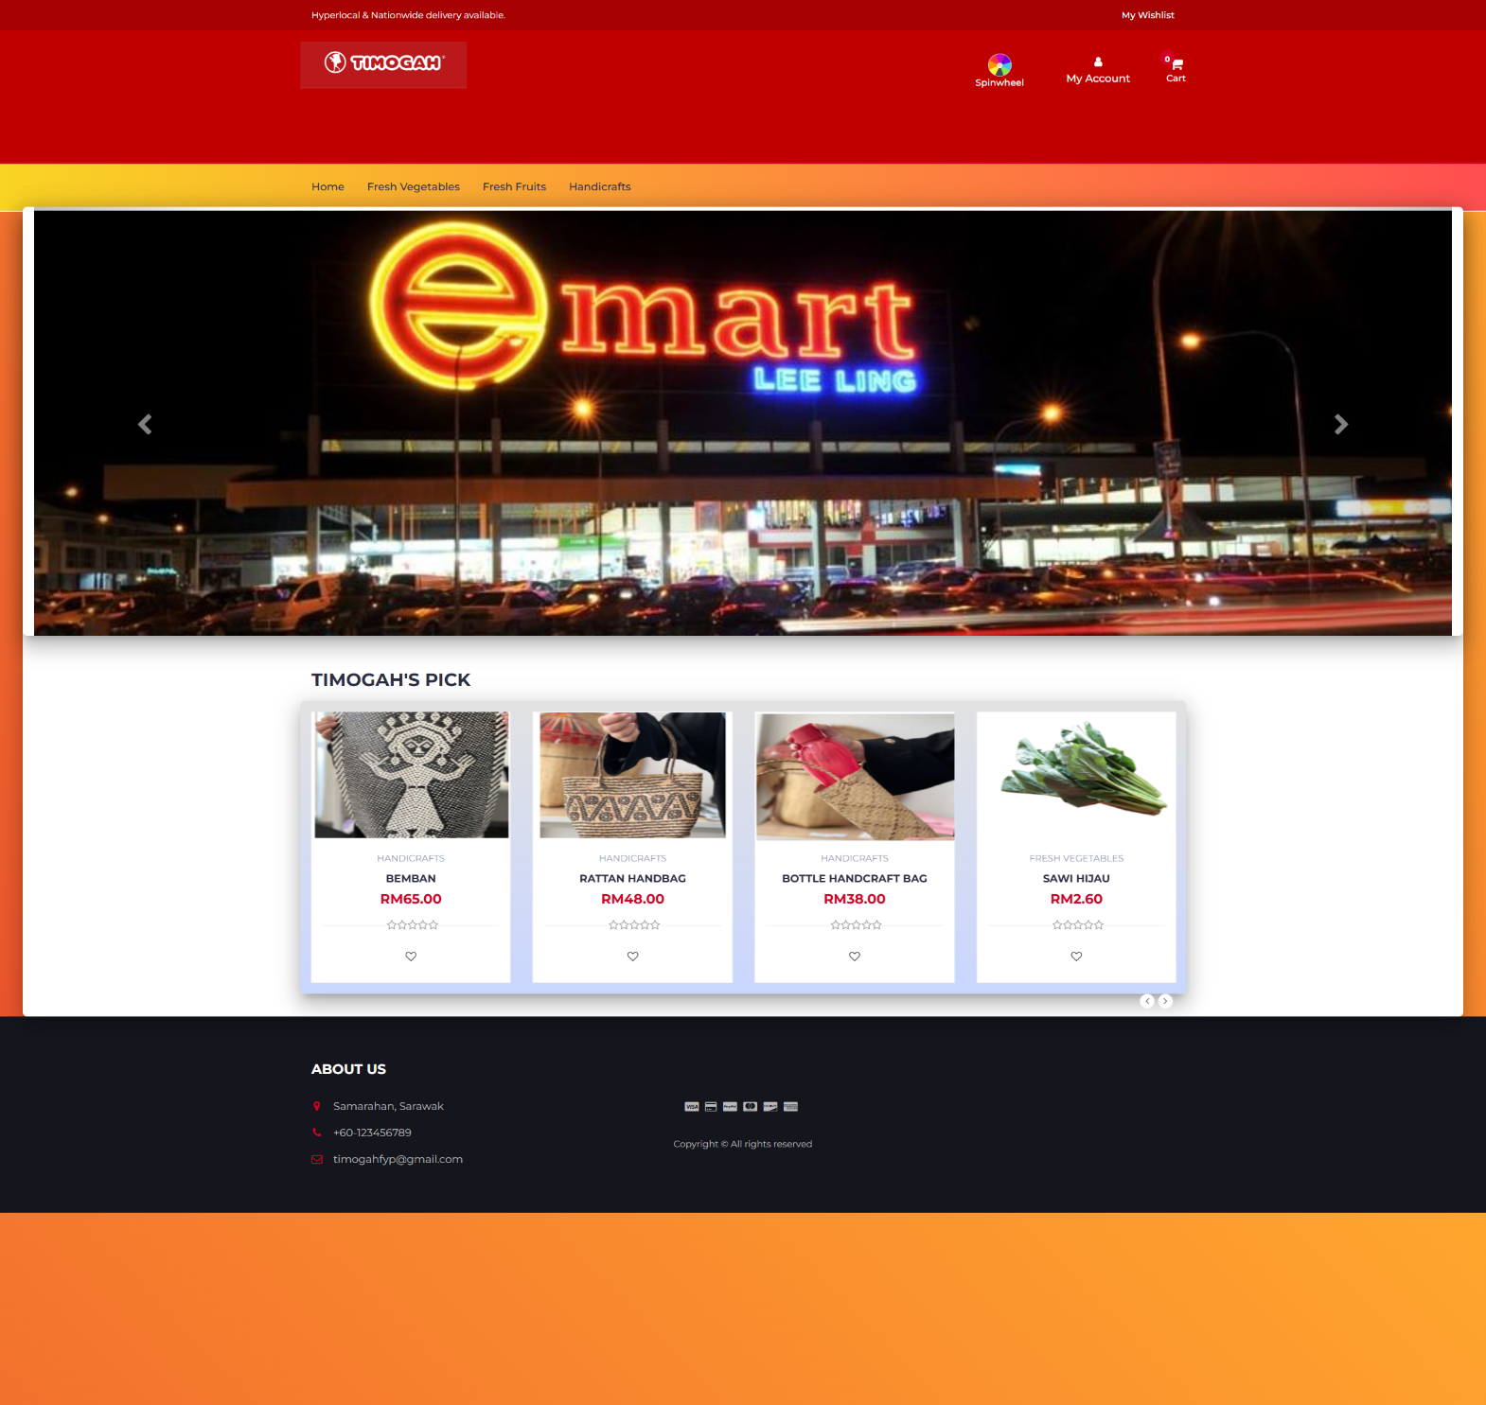

1. Guest can browse the Timogah main page by searching “http://localhost /timogah_fyp/index.php” in any browser.
2. By clicking the Timogah Logo, the guest is redirected to the main page.
3. The guest cannot access to the spinwheel mini game as it will redirect to login page.

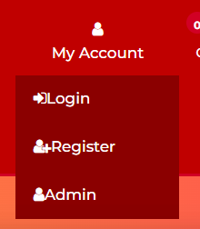

1. The guest hover to the “My Account” and “Login”, “Register” and “Admin” will be shown. The guest can login and register while admin also can login to admin page from “My Account”.

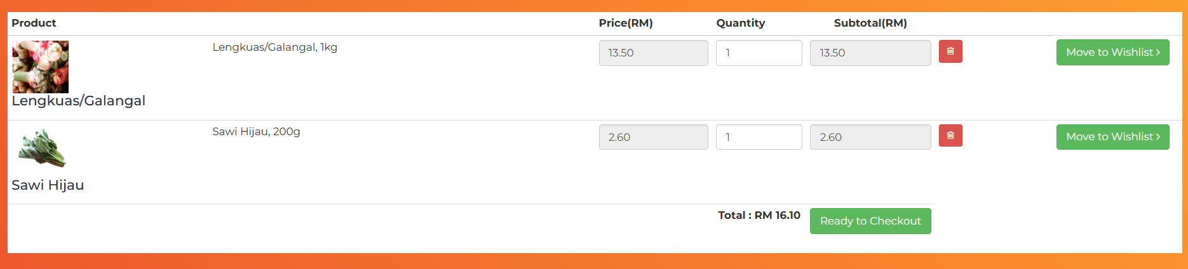

1. The guest can click on the “cart” at the header to navigate to cart.
2. The guest can edit the product quantity by key in number using keyboard or click on key up or down button and the subtotal and Total will calculate the price.
3. The guest can remove item from cart by clicking on the trash bin button.
4. The guest can move cart item to wishlist by clicking “Move to Wishlist”.
5. The guest cannot checkout as it will redirect to the sign up page.

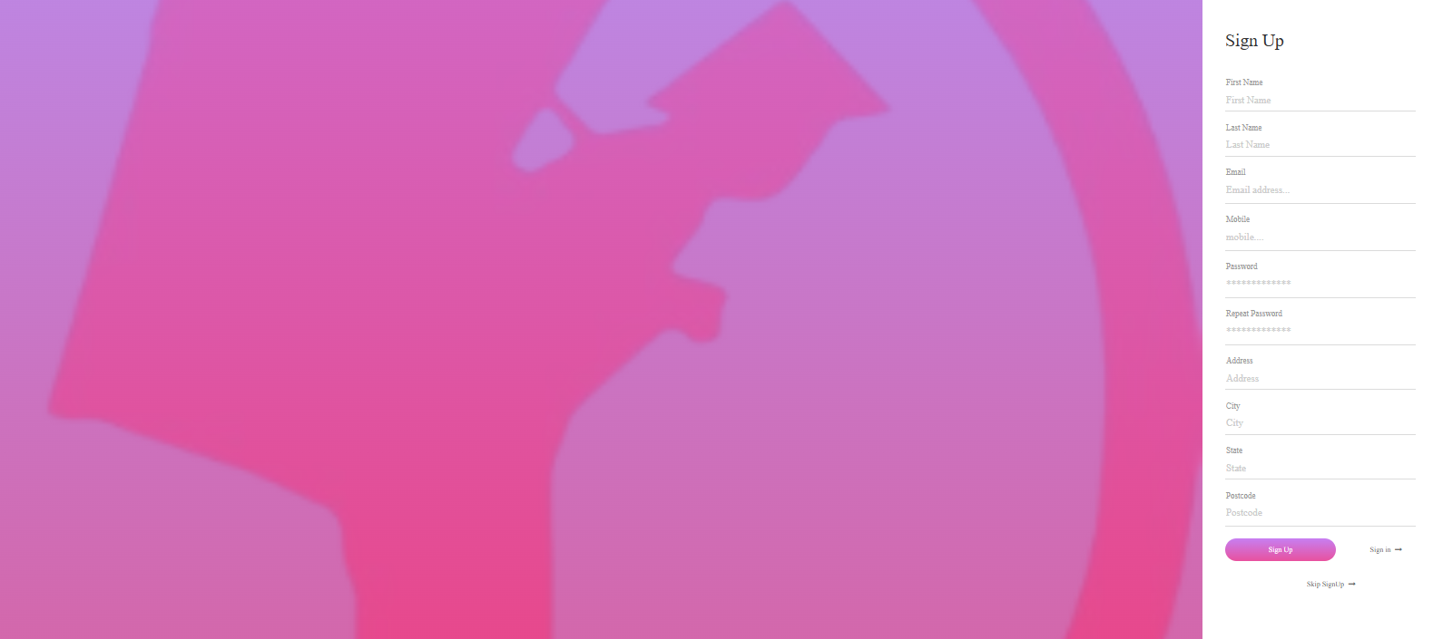

1. The guest registers as a new user by entering all valid required details.
2. The banner is not clickable as it is to showcase the guest about the stores and promotions.
3. The “Timogah’s Pick” showcase the suggested products by Timogah.
4. The guest can click on the “heart” shape icon to add item to wishlist.
5. The guest can click on the “wishlist” button at the top right of the top header to navigate to wishlist page.

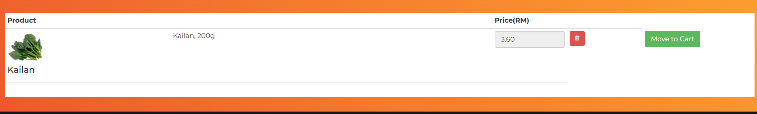

1. The guest can remove item from wishlist by clicking on the rubbish bin icon.
2. The guest can move item to cart by clicking “Move to Cart”.

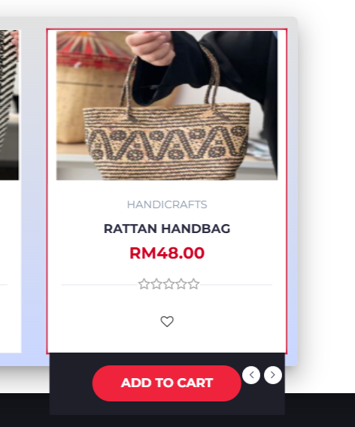

1. When the guest hover on the product, the “Add to Cart” button is shown, and guest can click on the button to add item to cart.
2. The footer of the website shows the information of the Timogah.

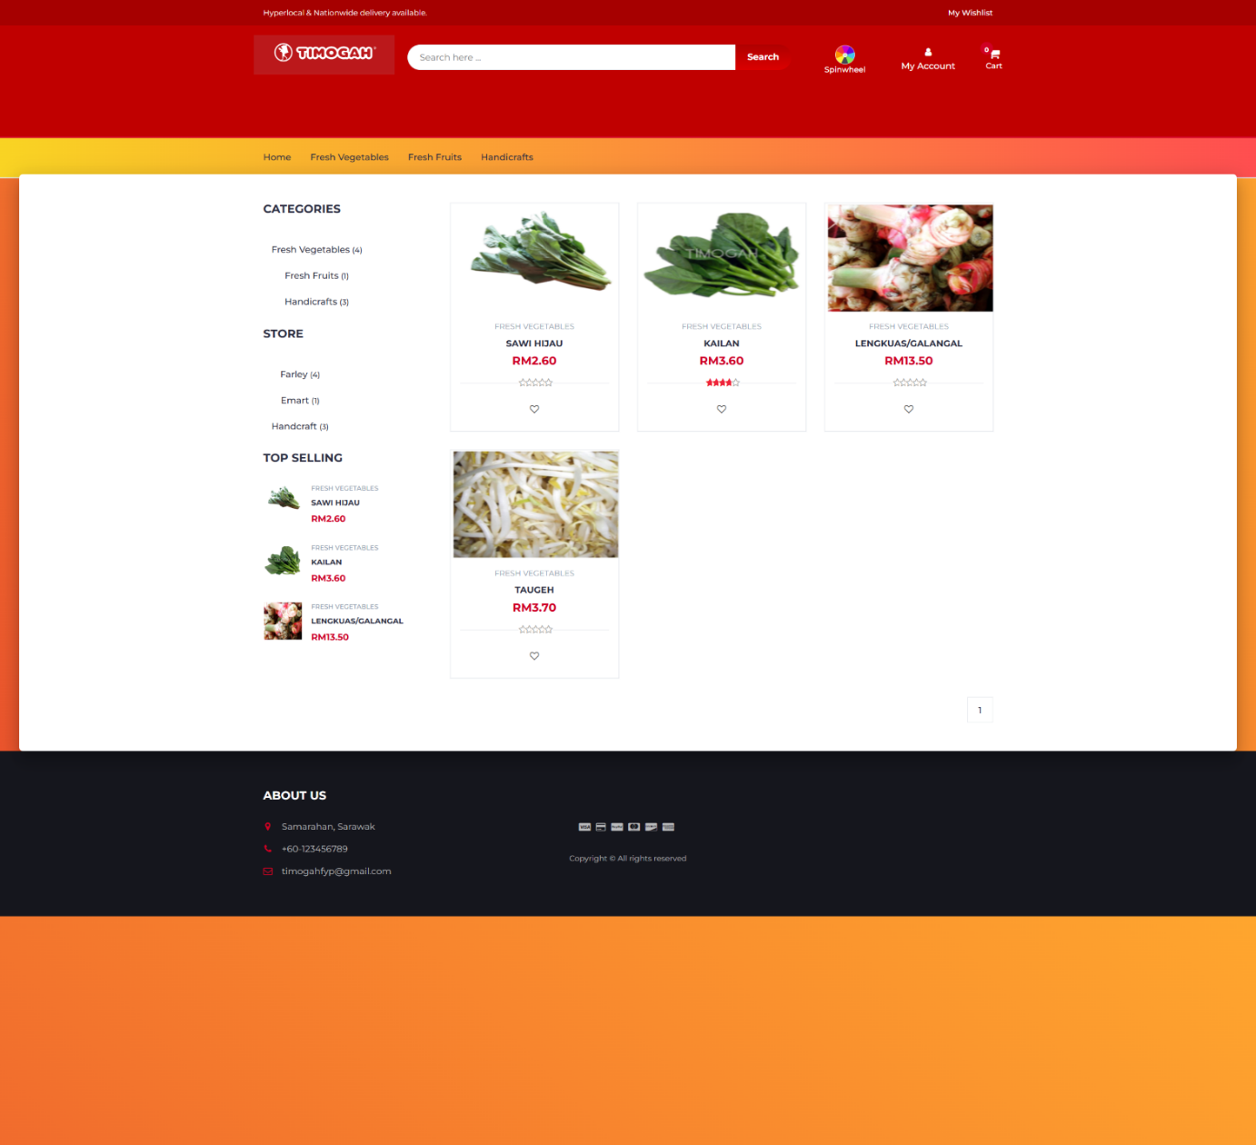

1. The categories of the products shown at the navigation bar are clickable as it will navigate guest to the list of products that is in the category.
2. The guest can key in keywords of the product at the search bar to search for products
3. The categories and store at the side is for guest to search products by sorting according to categories or stores.
4. The “Top Selling” shows the best seller of Timogah.

### User

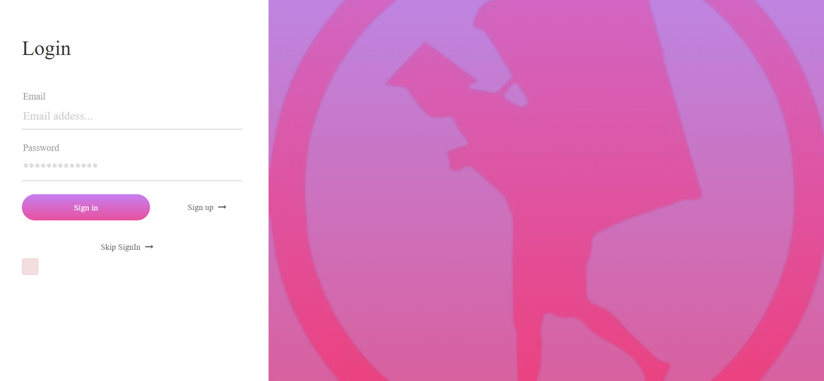

1. User login by entering valid email and password.

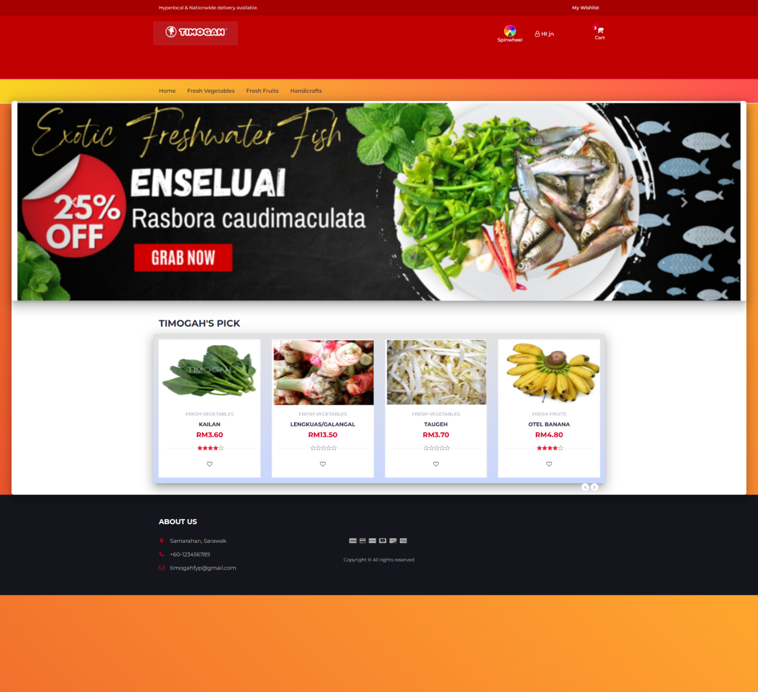

1. User can browse the Timogah main page by searching “http://localhost /timogah_fyp/index.php” in any browser.
2. By clicking the Timogah Logo, the user is redirected to the main page.



1. The user can click on the “cart” at the header to navigate to cart.
2. The user can edit the product quantity by key in number using keyboard or click on key up or down button and the subtotal and Total will calculate the price.
3. The user can remove item from cart by clicking on the trash bin button.
4. The user can check out by clicking “Ready to Checkout” button and will be redirected to checkout page.

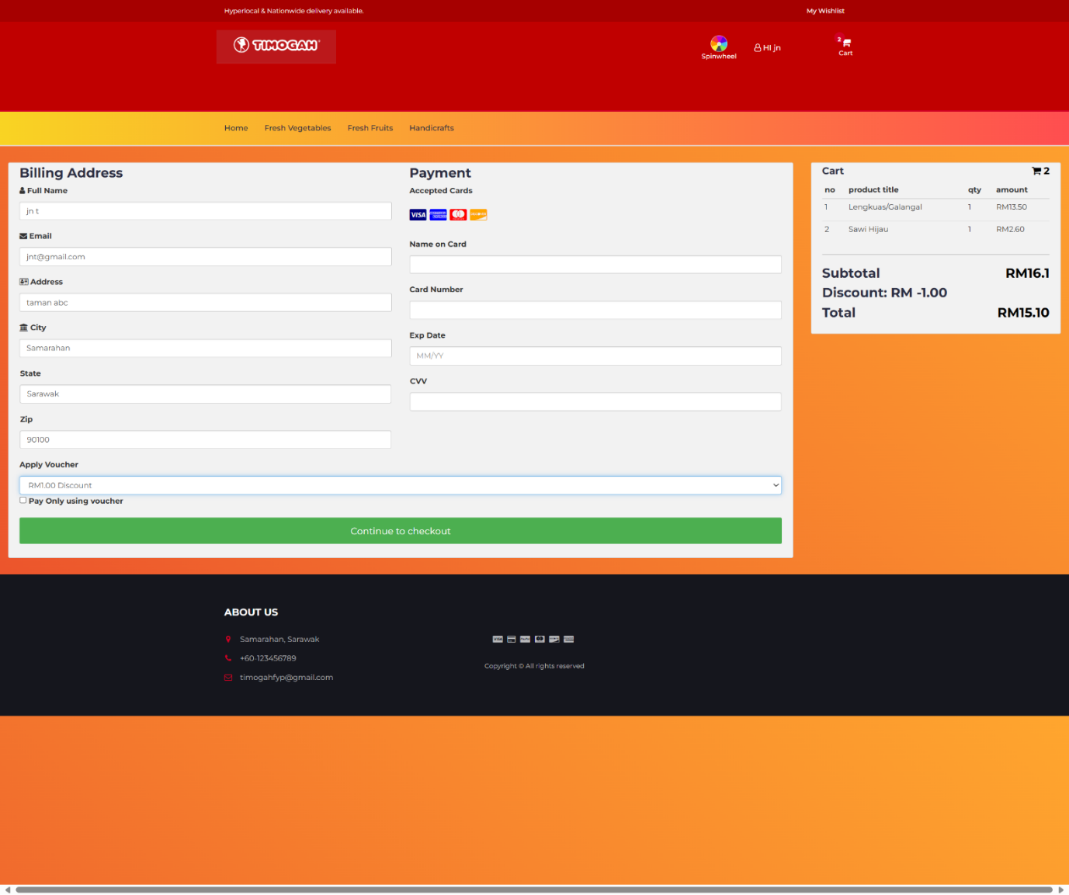

1. The user can proceed to checkout after filling all the required details and click on “Continue to Checkout”.
2. The user can apply voucher by selecting the dropdown at “Apply Voucher” section.
3. The user can check on “Pay Only Using Voucher” checkbox and no need to fill in Payment section if the user have enough voucher credit to discount the whole price.
4. The user can move cart item to wishlist by clicking “Move to Wishlist”.
5. The banner is not clickable as it is to showcase the user about the stores and promotions.
6. The “Timogah’s Pick” showcase the suggested products by Timogah.
7. The user can click on the “heart” shape icon to add item to wishlist.
8. The user can click on the “wishlist” button at the top right of the top header to navigate to wishlist page.



1. The user can remove item from wishlist by clicking on the rubbish bin icon.
2. The user can move item to cart by clicking “Move to Cart”.



1. When the user hover on the product, the “Add to Cart” button is shown, and user can click on the button to add item to cart.
2. The footer of the website shows the information of the Timogah.

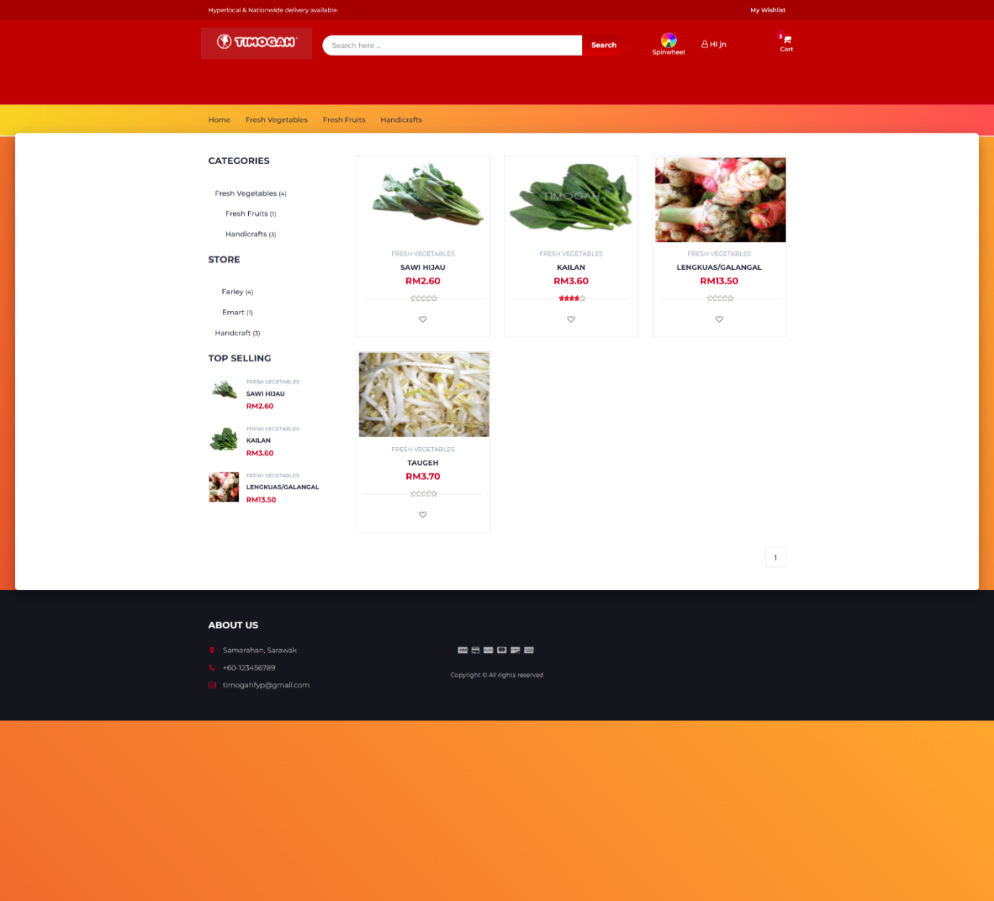

1. The categories of the products shown at the navigation bar are clickable as it will navigate user to the list of products that is in the category.
2. The user can key in keywords of the product at the search bar to search for products
3. The categories and store at the side is for user to search products by sorting according to categories or stores.
4. The “Top Selling” shows the best seller of Timogah.
5. The user can access to the spinwheel mini game by clicking spinwheel icon.

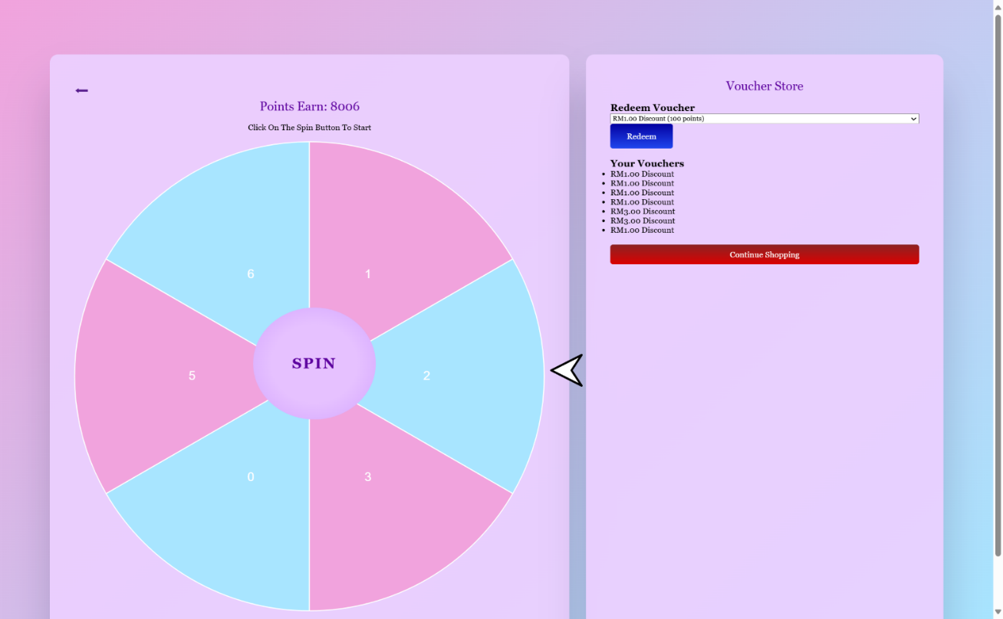

1. The user clicks on the “SPIN” button to spin the spinwheel.
2. The spinwheel stop and landed on the points will be the user earned point of the day as the user can spin once a day only.
3. The user can redeem voucher using points by choosing and selecting the voucher then submit.
4. Redeemed voucher will show on the “Your Vouchers” list.
5. The user can click on “Continue Shopping” button or “back arrow” to back to main page.

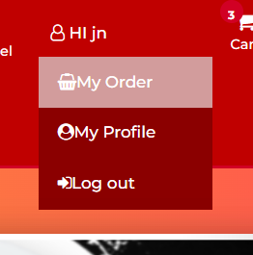

1. The user hover to the “Hi username” and “My Order”, “My Profile” and “Log out” will be shown. The user can navigate to My Order, My Profile and Log out.

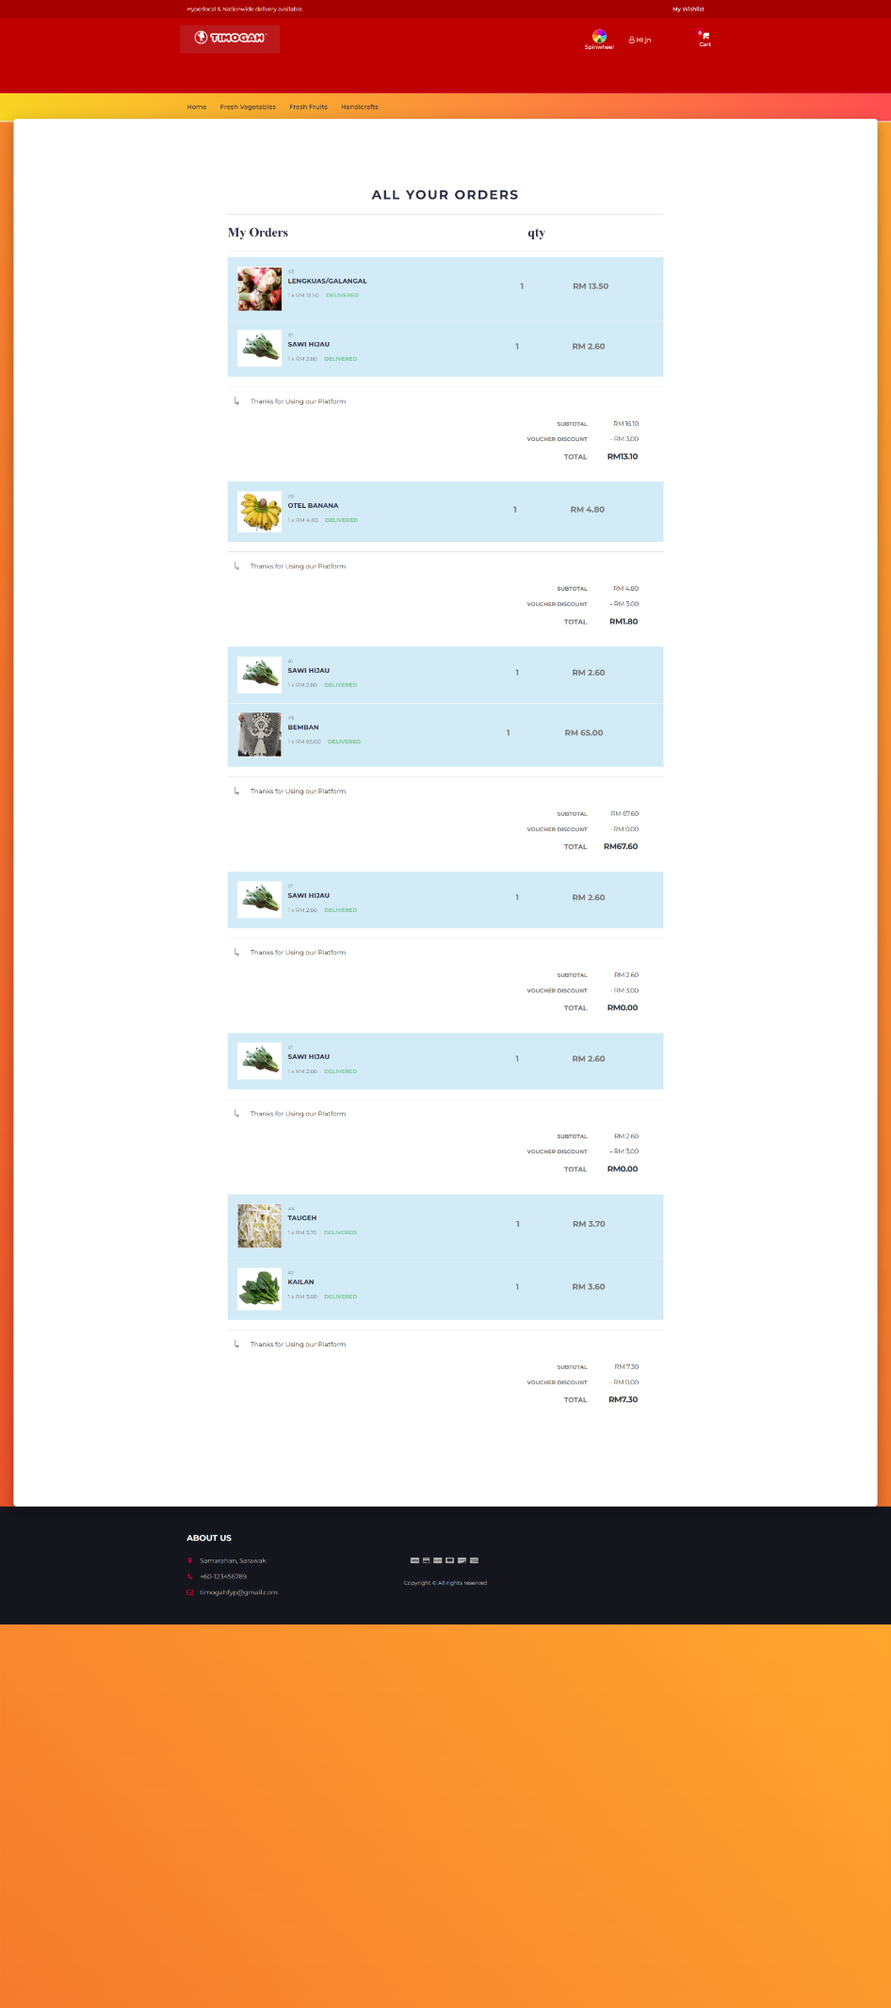

1. The user My Order page will show the order history.

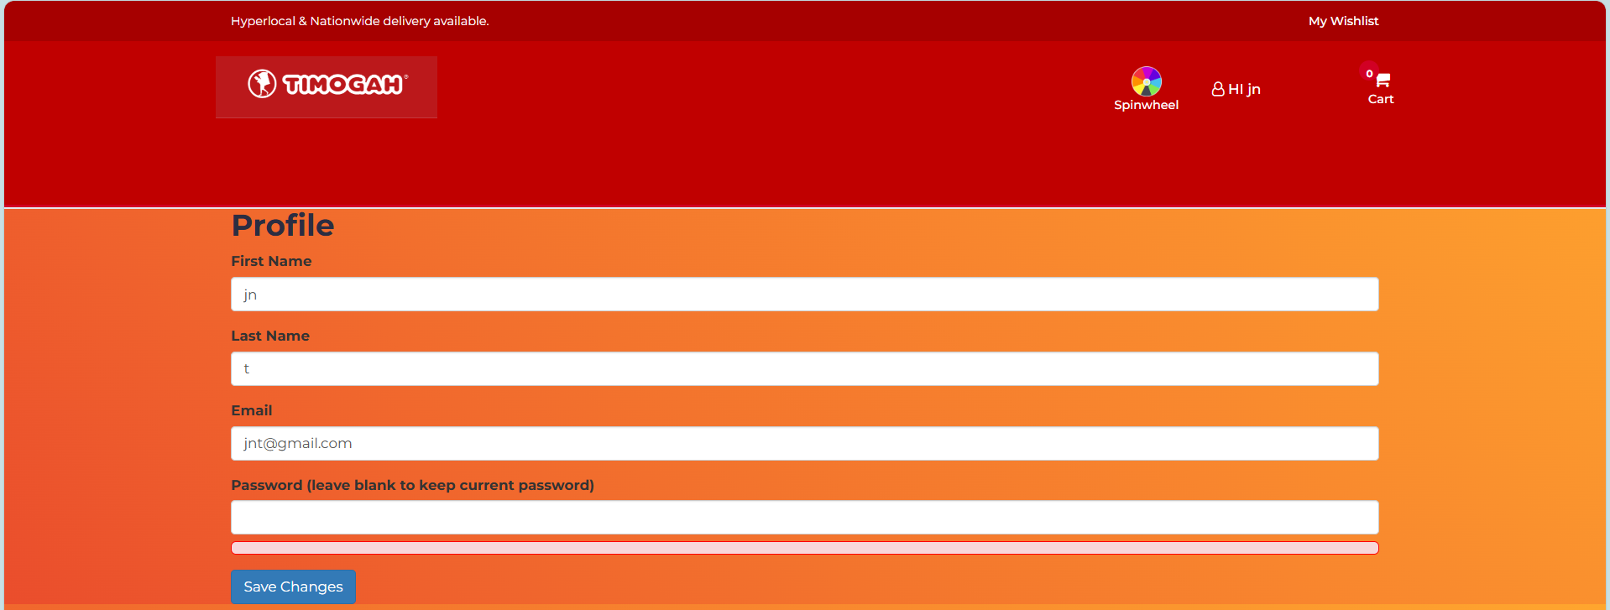

1. The My Profile show user profile and can edit user profile.

### Admin



1. The admin user login at the My Account by clicking Admin.

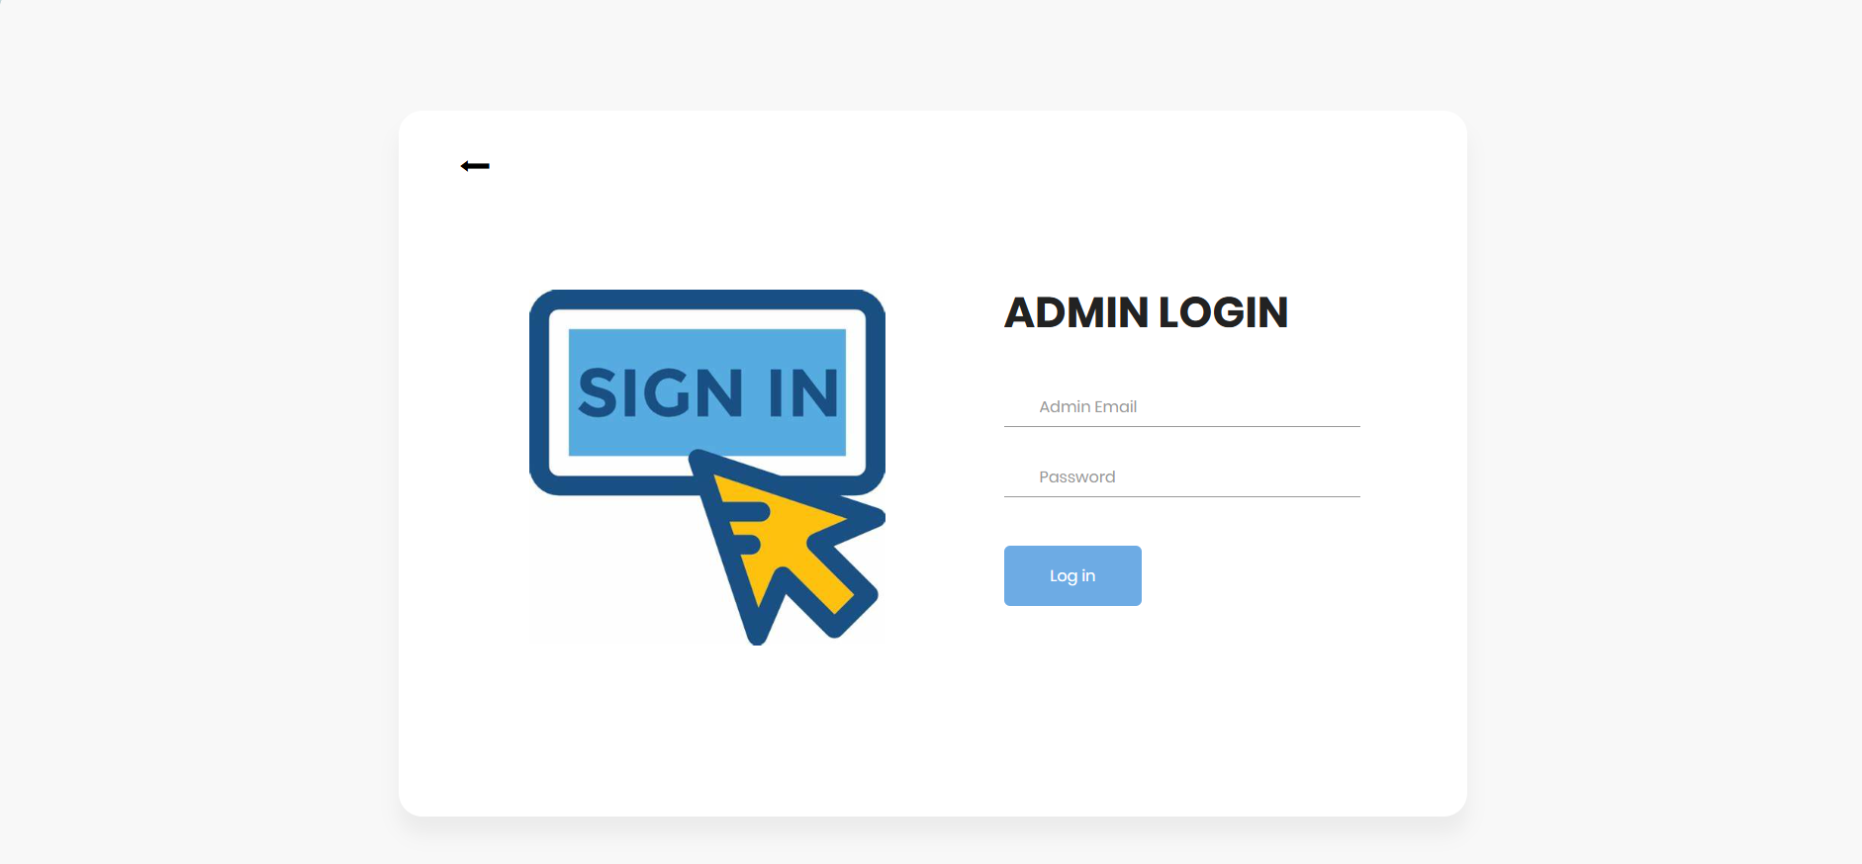

1. The admin redirected to admin login page key in valid admin email and password.

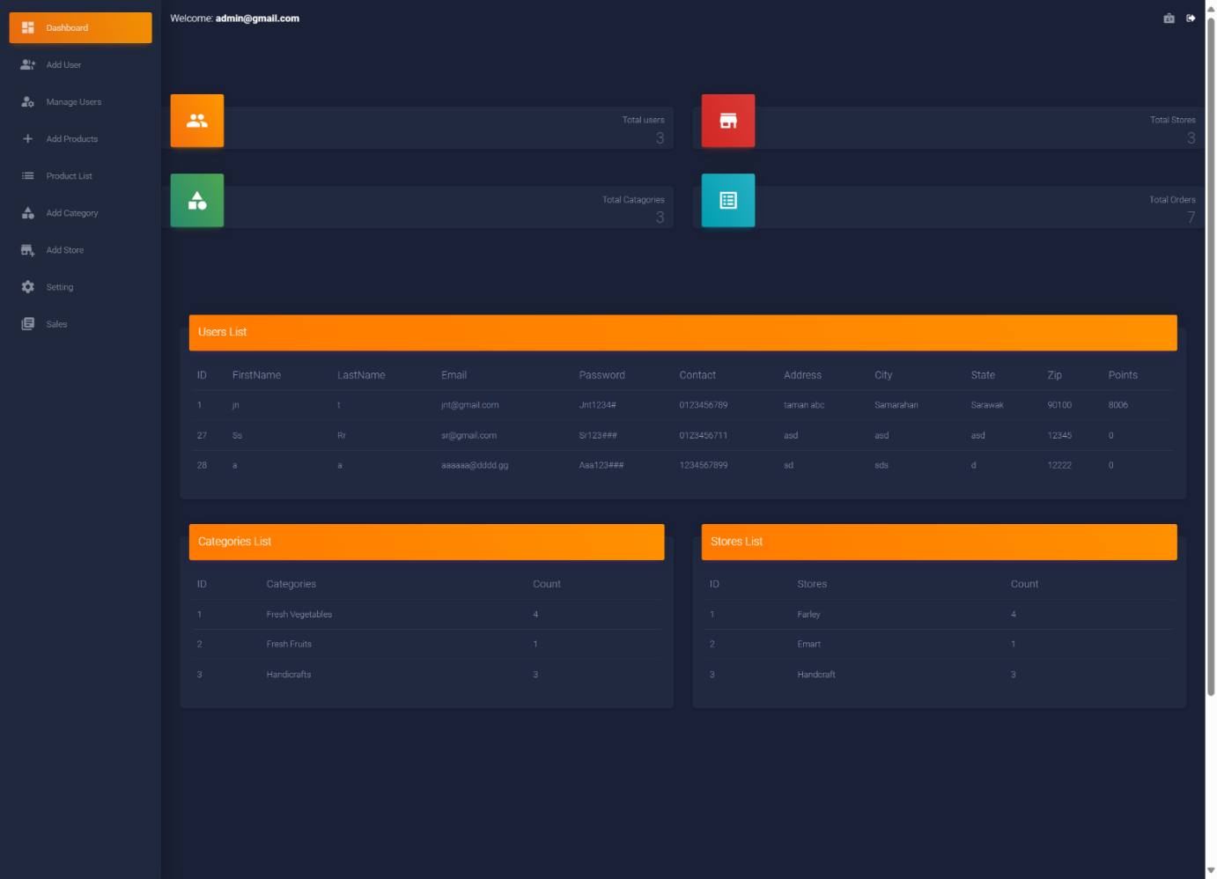

1. The system redirects to admin dashboard after admin logged in.
2. The admin dashboard welcoming admin, showing statistics of the Timogah system, user list, categories, stores and so on.
3. At the side bar, the admin can navigate to Dashboard, Add User, Manage User, Add Products, Products List, Add Category, Add Store, Setting, and Sales.

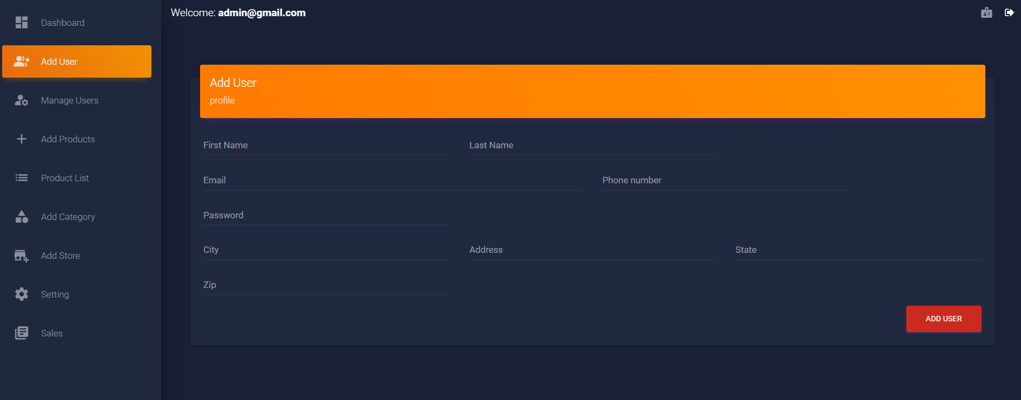

1. The Add user page shows a form for admin to fill in new user details to add new user.

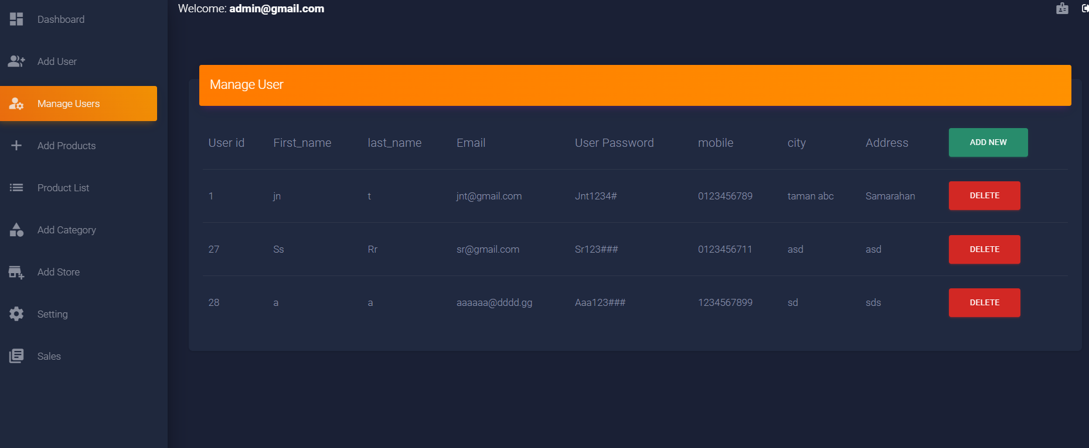

1. Manage users show list of users and have edit and delete button to edit or delete user.

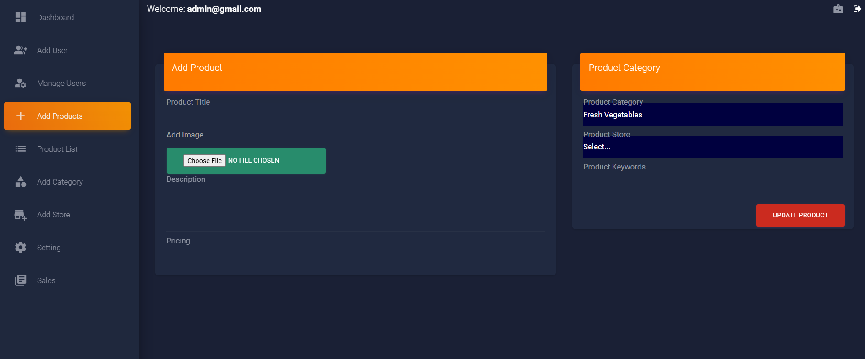

1. Add Products show the form for admin to fill in new product details and “Update Product” button to submit to the system.

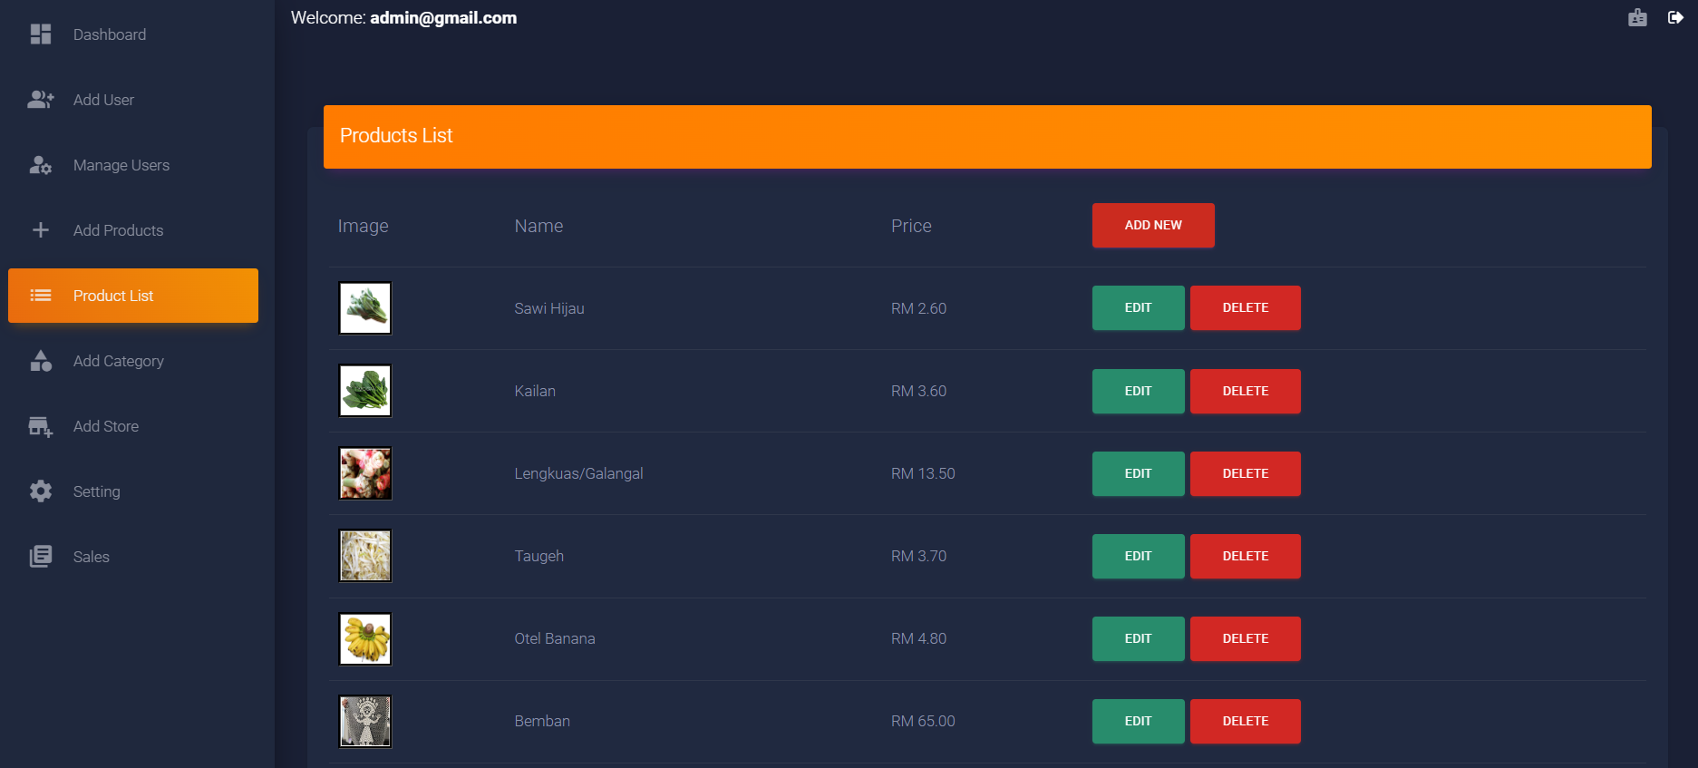

1. Product List show a list of products for admin to Add, Edit, View or Delete products.

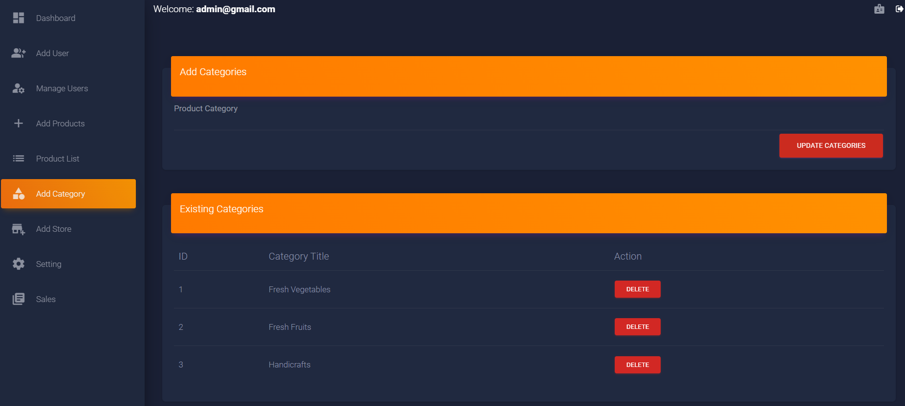

1. Add Category and Add Store are similar as it let user to key in new categories or stores and a list of categories and stores is shown below the form for admin to view or delete.

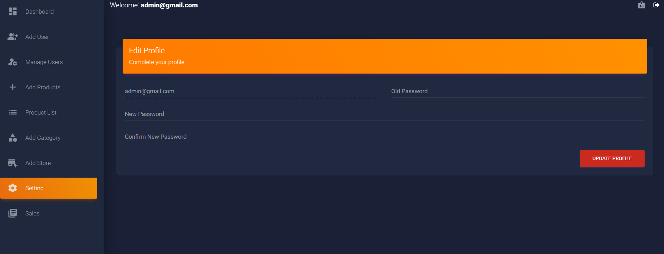

1. The setting in admin page is Edit Admin profile which is changing password.

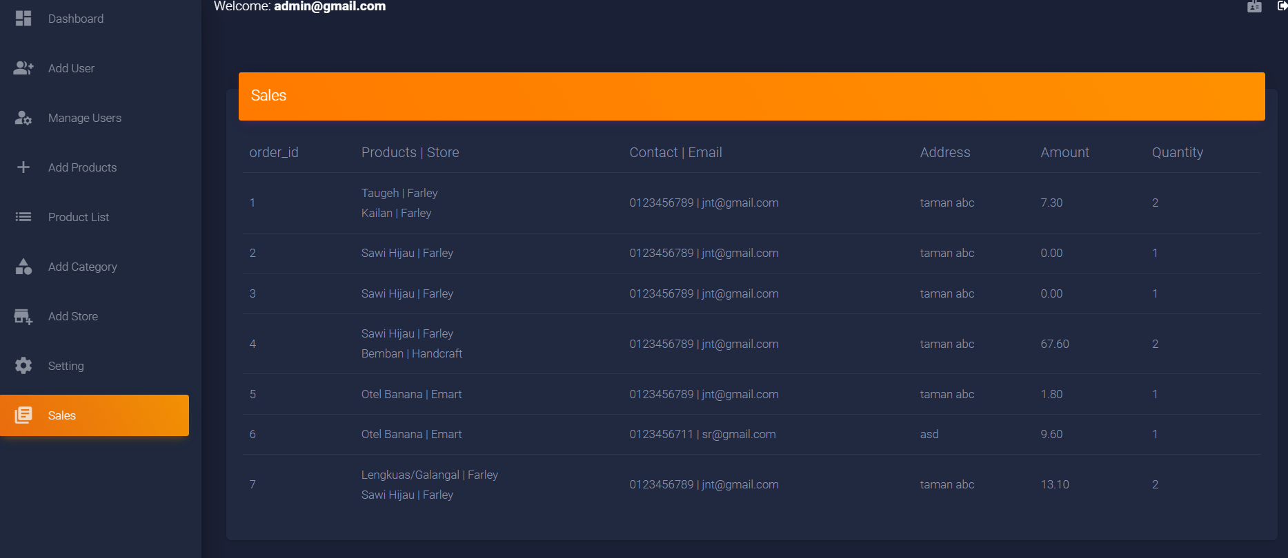

1. The Sales page show the sales details of the sales in Timogah system.
2. The admin can logout by clicking on the “door arrow out” button.
3. The admin can register new admin by clicking the “id card" button.

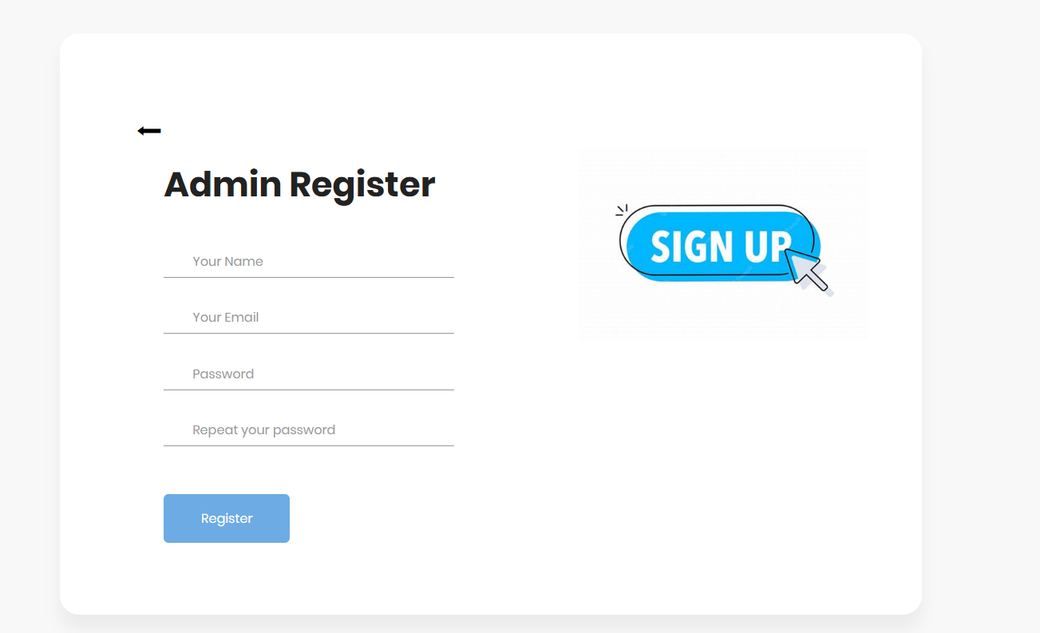

1. The new admin has to fill in required details to register as new admin.